**Fingerprint Based Voting System**

**An Engineering Project in Community Service**

**Phase – II Report**

***Submitted by***

**Shrutika Nikhar 19BCY10107**

***in partial fulfillment of the requirements for the degree of***

***Bachelor of Engineering and Technology***

**VIT Bhopal University**

**Bhopal**

**Madhya Pradesh**

**April, 2022**

**Bonafide Certificate**

Certified that this project report titled **“Fingerprint Based Voting System”** is the bonafide work of “Shreyas Bhagwat 19BCE10019, Prajakta Bhujang 19BCE10035, Saumya Verma 19BCE10173, Kanishk Joshi 19BCE10454, Krishan Kumar Gupta 19BAI10114, Adwitiya Dubey 19BAI10176, Shrutika Nikhar 19BCY10107, Siddharth Jain 19BCG10007**”** who carried out the project work under my supervision.

This project report (Phase II) is submitted for the Project Viva-Voce examination held on .

**Supervisor**

1.INTRODUCTION

Biometrics is the statistical evaluation for measuring biological information. It refers to technology that calculates and discovers human frame characteristics, along with DNA, fingerprint, retina, irises, voice or any form of noisy styles, facial patterns and hand gesture degree, for authentication and verification purposes.

In our research, we've used fingerprints for the cause of voter identification and authentication. As every and each person has unique fingerprint patterns, it enables them to gain maximum accuracy.

A database is developed that stores fingerprints of every character inside the constituency. So, It checks the unlawful and the repetition of votes. therefore the elections could be performed fair and loose from any form of rigging.

“Fingerprint Based Voting System” is the device we designed that allows the consumer to vote smoothly and successfully. The vote casting gadget may have server offerings which are related to a far flung hyperlink database for storing continual data. Admin will preserve all records concerning voter and answerable for truthful conduction of the elections.

The purpose of this venture is to conduct an election effortlessly and effectively. For this reason, the election may be truthful and loose from any horrific exercise. This project intends to make an election dynamic. So, any number of candidates can follow for the election.

**1.1 MOTIVATION**

In developing countries like "INDIA", the election commission follows a manual voting mechanism which is done by the electronic voting machine. The poll percentage of India has never exceeded 67% till date. We have come up with an innovative solution to solve all the above-discussed problems.

The main problem is people either do not leave in the area where they are registered as a voter or they do not go to the poll center because of any other reason. The queue at the poll center is also one of the major reasons for less poll percentage. Some people cast their vote, and approximately 2% of the vote each time become invalid, due to any reason.

## **1.2** **OBJECTIVE**

The Fingerprint Based Voting Project is an application in which the user's finger pattern is used to identify the person (or any other biometrics in the future). Because each person's finger pattern is unique, the voter can be easily identified. The method allows the voter to cast his vote by scanning his fingerprint. The fingerprint is used to identify the individual in a unique way. Each person's fingerprint has its own unique set of traits. The voters' fingerprints are used to verify their identity. A voter can only vote for a candidate once; the system will not enable the candidate to vote again. The system will allow the administrator to upload the names and photos of candidates who have been nominated for the election.

2.1 EXISTING WORK

### EVMs & Current Scenario

Elections are the strength of democracy, but all too frequently, We never care about the mechanism of the election. Electronic Voting Machines (“EVM") was commissioned by the Chief

Election Commissioner in 1977. The EVMs were designed and manufactured by Election Commission of India in collaboration with Bharat Electronics Limited (BEL) and Electronics Corporation of India Limited (ECIL)

EVM consists of two major units, i) Control Unit, ii) Balloting Unit. The two units are interfaced by a five-meter cable. The Control Unit is with the concerned officer assigned and the Balloting Unit will be kept inside the voting compartment.

### Problems with the current scenario

1. **Security Problems:** Individuals can change the program installed in the EVM and can tamper the results after the polling for the favor of the candidate.
2. **Illegal Voting (Rigging)**: Rigging is the most common problem faced by the election commission of India.In which an individual cast more than one vote in a different constituency
3. **Manual adding of candidature:** India is a democratic country, Each and Every individual has right to stand at the election, If a large number of candidates contest the election it will create difficulty for the election commission to conduct elections. Since our project is dynamic, we can add as many candidates we want.

2.2 LITERATURE REVIEW

**2.2.1 What are elections and their types?**

An election is a formal decision-making process in which a population or society chooses someone to hold a political position. Elections have been the standard process through which contemporary representative democracy has functioned since the 17th century. Elections are held by both public bodies such as the government and private and corporate groups, such as choosing representatives for a company's Board of Directors, professional club leadership, and even in voluntary associations.

There are multiple sorts or categories of elections held in most democratic political systems, which correlate to the various tiers of public government or geographical jurisdiction. Presidential Elections, Parliamentary Elections, Governorship Elections, and Local Government Elections are examples of common election categories.

#### **2.2.2 Evolution of Voting Equipment**

Voting technology that has been widely used in recent years may be classified into five sorts.

**2.3.2.1. Paper-based Voting:** The voter receives a ballot paper and uses a pen or marker to select the candidate he wishes to vote for. Hand counting votes is a time-consuming and labor-intensive operation, but because paper ballots are affordable and can be kept for verification, it is still the most frequent way to vote.

**2.3.2.2. Lever Voting Machine:** A lever machine is a piece of equipment, and each lever is allocated to a certain applicant. The voter pushes the lever in order to vote for his preferred candidate. This type of voting system can automatically count the ballots. Voters will need to be trained because the interface is not user-friendly.

**2.3.2.3. Direct Recording Electronic (DRE) Voting Machine:** It combines a touchscreen, keyboard, or buttons for voters to press to poll. It creates a tabulation of the voting data saved in a detachable memory as well as a printed copy after the election. However, the accuracy of the other DREs who do not preserve voting records is questioned.

**2.3.2.4. Punch Card:** The voter punches a hole in the blank ballot with a metallic hole-punch. It can automatically count votes, but if the voter's perforation is incomplete, the outcome will almost likely be incorrect.

**2.3.2.5. Optical Voting Machine:** This system chooses the darkest mark on each ballot for the vote after each voter fills in a circle corresponding to their preferred candidate on the blank ballot, then computes the overall result. This type of equipment quickly counts votes. If the voter, on the other hand, fills in the circle completely, the optical scan will result in an error.

#### **Electronic Voting in India**

In India, electronic voting is the conventional method for holding elections using Electronic Voting Machines, sometimes known as "EVMs." In the 1990s, the state-owned Electronics Corporation of India (ECIL) and Bharat Electronics Limited (BEL) developed and tested electronic voting machines. They were deployed in some areas of the country, but they were never largely accepted. They pioneered the sort of system that is still in use today, including the distinct control and ballot units, as well as the structure of both.

The original EVMs featured Hitachi 6305 microcontrollers and firmware stored in external UV erasable PROMs, as well as 64kb EEPROMs for saving votes. Both ECIL and BEL released the second-generation models in 2000. These machines upgraded additional components as well as moving the firmware inside the CPU. Beginning in 2004, they were gradually deployed in larger numbers and used across the country. The makers chose a third-generation design in 2006, which included further adjustments suggested by the Indian Election Commission.

3. TOPIC- FINGERPRINT BASED VOTING SYSTEM

* Voter can sign up and fill his/her verified details for the election.He/She will also register their fingerprint on the system.
* After registration, Voter can login in his/her account using his.her voting id and DOB and will be verified with a fingerprint.
* After successful login, voters will be provided with a choice of selecting any party of their preference displayed with the respective name and party logo.
* All the votes would be counted and stored in a secured database and at the end of the election result will be announced.

# **a) System Design / Architecture**

The system has 1 major module and its submodules:

1. Admin Login

a. AddCandidate: -> Admin can add as many numbers of candidates dynamically who wanna contest the election.

b. Add Election: -> System allows admin to add election.

c. View Election: -> After creating an election, the admin would be able to see the details of the election except who cast votes to whom.

d. Add Voter: -> System allows admin to register voters by scanning their thumb impressions and storing their details into the remote database.

e. View Result: -> Post elections admin can view results and can check who won the election.

**Block diagram**

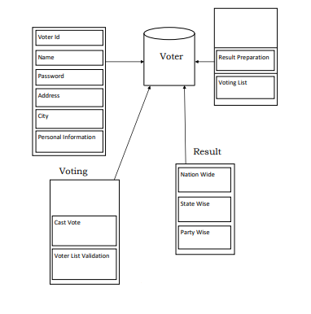

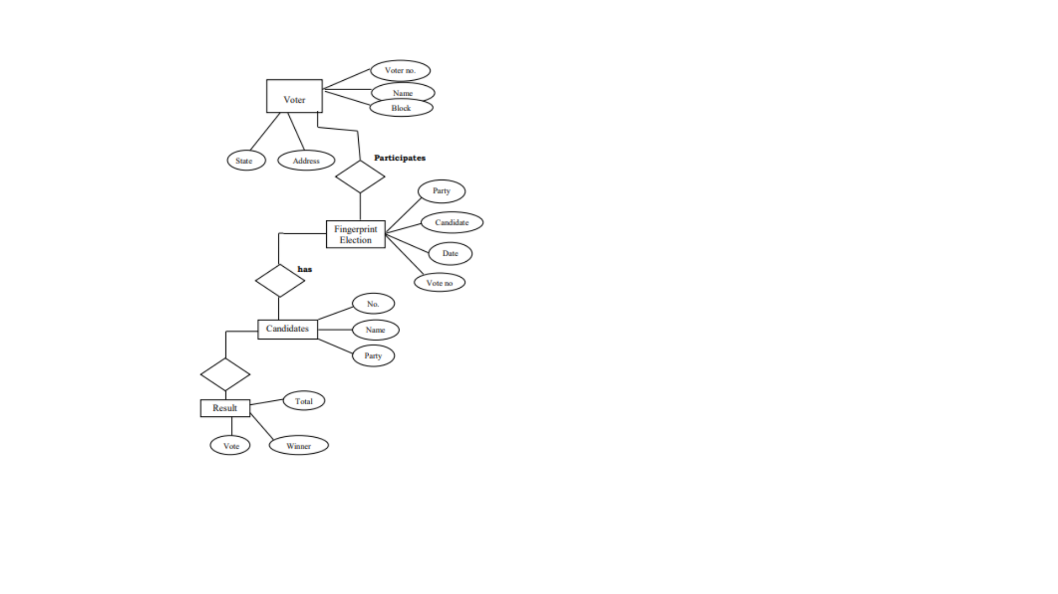

**ER Diagram**

**b) Working Principle**

Prior to the voting process, all potential voters' fingerprints must be registered with the system in order for them to cast their votes during the voting process. After the fingerprints have been registered, the voting process can begin, with voters casting their votes for the candidate of their choice. After successful registration of fingerprints, users with registered fingerprints are eligible to vote.

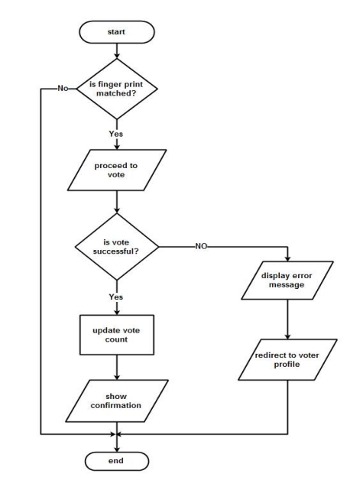

**c) Expected Output**

The voter with an appropriate voter id will get the menu to cast the vote to their desired candidate contesting the election. If the voter wants to view the profile or image of the candidate, then he/she can by clicking on the view profile. For voting the particular candidate, the user has to provide a fingerprint as input to the system. This unique fingerprint data will then be processed by algorithm for authenticity and proxy check. Further after the successful contest of election all the casted votes will increase the count of the candidate, not storing individual vote casting to whom. The result then will be pure and can also be transformed in the form of .xls or excel file for future analysis.

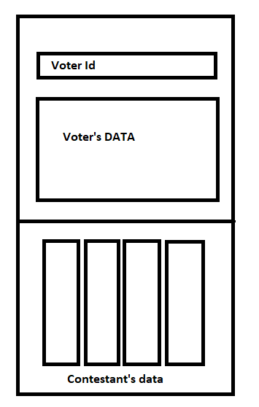

**Expected outcomes**

For our EPIC project fingerprint voting system to achieve its expected output, the main goal is to remove Vulnerability to Authenticity. Our expected aim will be contesting a fair and unbiased election.

Where,

1. The working software will allow the user to vote for only one candidate.
2. The working software will allow the user to vote one time for a particular election.
3. Host can add any number of candidates when the new election is announced.
4. Host can view the election result by using the election id.
5. Achieving maximum voting rate
6. Voting from home or individual place
7. Removes concept of mass gathering at polling booth
8. Efficient way in situations like pandemic
9. Very helpful for online competitions

10.Unique verification ensures authenticity

# 

# **4.** **CONCLUSION**

In total, this system overcomes most of the problems that are faced in the traditional approach of the voting system. The efficiency of this system depends upon the web interface, its usability. This will surely ensure a safer voting method which is very much what is required for the healthy growth of a developing nation.

The proposed fingerprint based voting system which is better and faster than the previous system. The new system prevents access to illegal voters, provides ease of use, transparency and maintains the integrity of the voting process. The system also solves the problem of RIGGING, meaning it does not allow a user to vote multiple times since his fingerprint is recorded once in an election. The system does not allow the voter to vote for more than once in the same election.

The fingerprint-based voting system has provided a chance to avoid invalid votes, it reduces the polling time, easy carrying to polling center from the polling box, reduces the staff of the voting center, It provides easy and accurate cutting without any trouble. The developed system provides an interface to the user where the user will be shown the list of candidates along with their basic pieces of information. The voter needs to be first registered with the system after that only he/she will be allowed to vote in the election.

The system provides the result in a very short span of time without any errors. It reduces the possibility of changing votes or favoring any candidate. The system is totally automated and does allow even the admins to change the vote. It does not allow the admins to see who has been the vote cast by the voter.

Not only this, but It will also save the time which is spent in distributing and restoring the boxes to the ECI. It can be started with minimum system configuration and a fingerprint sensor.

Individual Contribution:

**Shrutika Nikhar (19BCY10107) – Database Creation and Management**

My individual contribution to the project was to create a functioning database for this project. I was tasked with creating a database repository and setting up the data tables for two main components namely 'voters' and 'parties' participating in the election.

My major contributions are :-

* Creating MySql voter database for the server.
* Creating a MySql parties database for the server.
* Built structure and design of databases.
* Ensured effectiveness of database and its efficiency.
* Setting up and testing of the databases.

**The Database Process:**

**Step 1:**

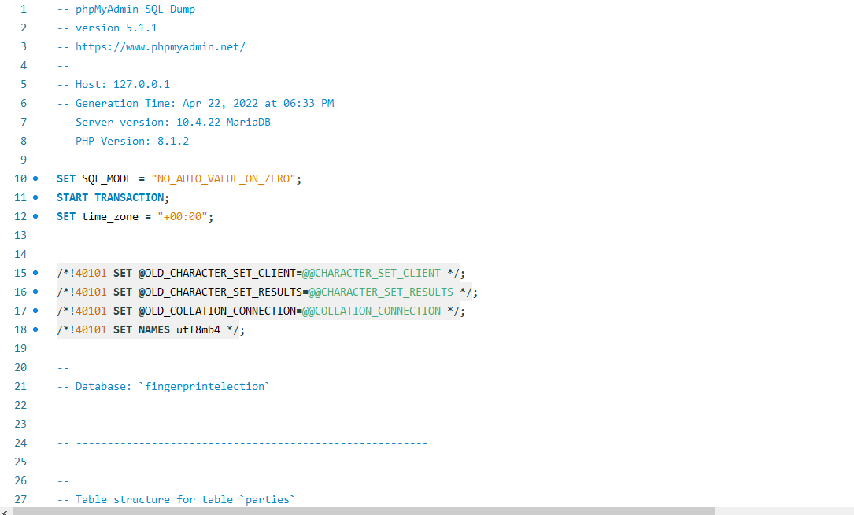

**Step 2:** Designing table for parties. Here the table has two fields, namely ‘party’ and ‘vote_count’.

* Set party to varchar(40).and NOT NULL (This will ensure that the column will not accept null values)
* Set vote_count to int(11) to DEFAULT NULL (The column can take NULL as a value, when defined with explicit DEFAULT NULL clause)

Code:

CREATE TABLE `parties` (

`party` varchar(40) NOT NULL,

`vote_count` int(11) DEFAULT NULL

)

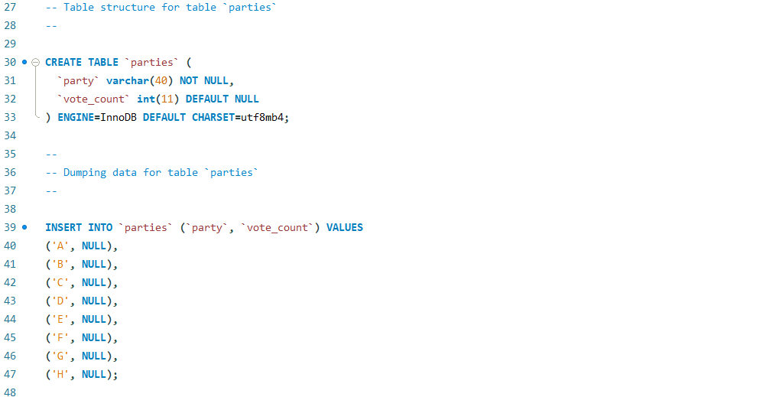

**Step 3:**

Create table for voters named ‘voter’ with following fields:

Code:

CREATE TABLE `voter` (

`voter_id` varchar(10) NOT NULL,

`name` text NOT NULL,

`surname` text NOT NULL,

`middle_name` text NOT NULL,

`gender` text NOT NULL,

`birthdate` date NOT NULL,

`address` varchar(100) NOT NULL,

`contact_no` bigint(11) DEFAULT NULL,

`email` varchar(30) DEFAULT NULL,

`fingerprint` mediumblob DEFAULT NULL,

`password` varchar(255) DEFAULT NULL,

`signed_up` tinyint(1) DEFAULT NULL,

`voted_party` text DEFAULT NULL,

`date&time` timestamp NOT NULL DEFAULT current_timestamp() )

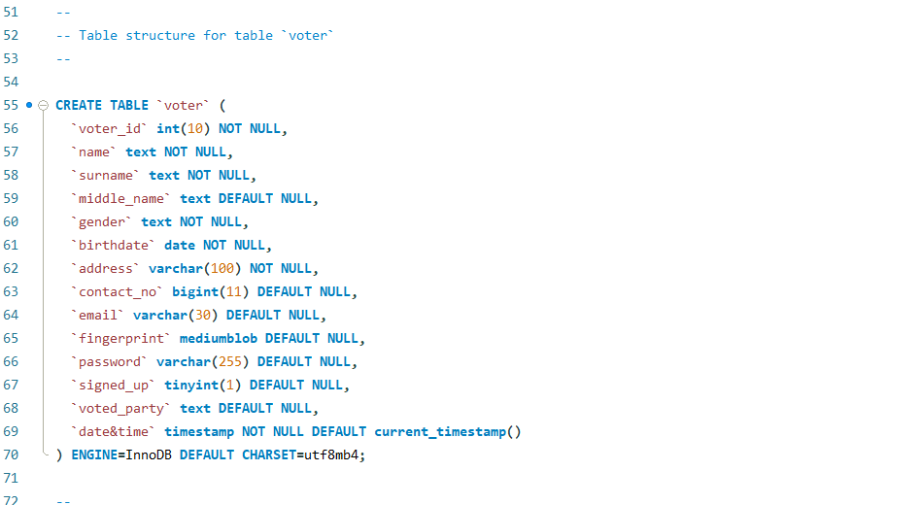

**Step 4:** After voter table creation the next step is to add the values for multiple voters manually for the following fields

* voter_id,
* name,
* surname,
* middle_name,
* gender,birthdate,
* address ,
* fingerprint

leave the remaining field null.

Code:

INSERT INTO `voter` (`voter_id`, `name`, `surname`, `middle_name`, `gender`, `birthdate`, `address`, `contact_no`, `email`, `fingerprint`, `password`, `signed_up`, `voted_party`, `date&time`) VALUES

(101, 'Dixit', 'Upadhyay', 'Shankar', 'Male', '2001-12-23', 'house 203 Shankarnagar', 3574916378, 'dixitupa@gmail.com', NULL, 'password01', NULL, NULL, '2022-04-21 11:12:34'),

(102, 'Shreyas', 'Bhagwat', 'S', 'Male', '2001-02-28', '132 panchwati', 7987685319, 'bhagwatshreyas01@gmail.com', NULL, NULL, NULL, NULL, '2022-04-21 17:57:24'),

(103, 'Sakshi', 'Mahant', 'Ankit', 'Female', '1995-02-13', 'flat 401 Ashok Villa', 4635616378, 'sakshimahant@gmail.com', NULL, 'password02', NULL, NULL, '2022-04-21 11:17:57'),

(104, 'Shyam', 'Tele', 'Ravi', 'Male', '2001-06-04', 'plot 34 Rameshwar nagar', 9112316378, 'Shyamtele@gmail.com', NULL, 'password03', NULL, NULL, '2022-04-21 11:17:57'),

(105, 'Akansha', 'Shende', 'Shikhar', 'Female', '1999-04-12', 'house 45 Venkatesh', 8514316378, 'akashende@gmail.com', NULL, NULL, NULL, NULL, '2022-04-21 11:17:57'),

(106, 'Akshay', 'Bele', 'Dhruv', 'Male', '1998-12-07', 'house 203 city center', 7764536378, 'akshaybele@gmail.com', NULL, 'password05', NULL, NULL, '2022-04-21 11:17:57');

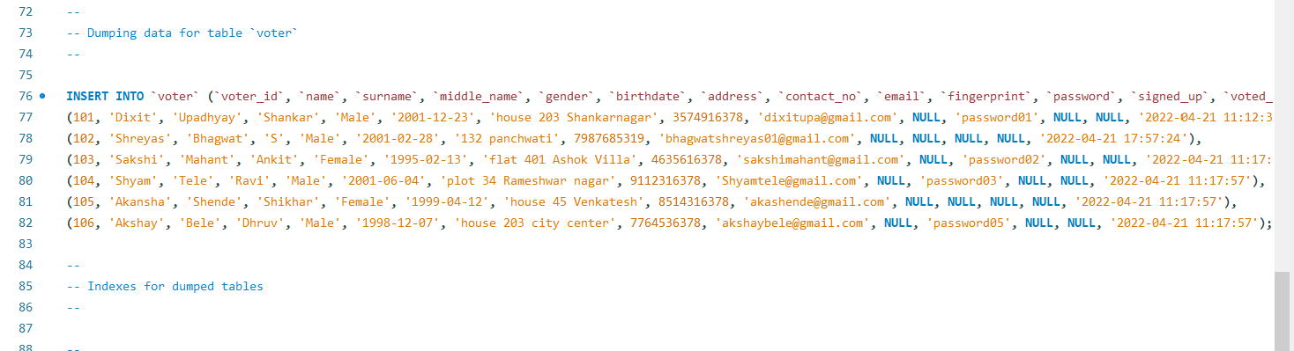

**Step 5:**

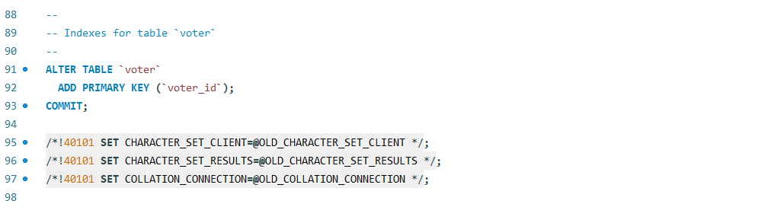

**Siddharth Jain (19BCG10007)** – **Hardware Integration**

My part of the work in the project is to successfully integrate an external USB fingerprint sensor, which starts from choosing an appropriate fingerprint scanner having a desirable SDK and API that enables perfect integration over various Android and Windows platforms. Where the main work for this hardware is to read the fingerprint of the user as input and save its unique identification in the database. Further after successful sign up as a voter, its work is to verify the user and further allow him to vote or not

Major contributions are:-

.

* Enabling Safran Morpho Icons MSO 1300 E3 Biometric Fingerprint Scanner with RD Service as the fingerprint hardware.
* Integrating a swift MSO SDK for working with the scanner.

(desired SDK for the particular scanner)

* Establishing communication to modules.
* Capturing the fingerprint and returning the fingerprint, template, and image
* Using XAMPP for uploading the template to the database.
* Using XAMPP for testing the efficiency of flow over the local server.

**Shreyas Bhagwat (19BCE10019)** – **Server-side Web Application**

I contributed to this project by writing server-side web application logic in JavaScript and developing back-end components. I also supported the front-end developers by integrating their work with the Node.js application.

Major contributions are:-

* Developed and maintained all server-side network components.
* Ensured optimal performance of the central database and responsiveness to front-end requests.
* Collaborated with front-end developers on the integration of elements.
* Developed high-performance applications by writing testable, reusable, and efficient code.
* Implemented effective security protocols, data protection measures, and storage solutions.
* Ran diagnostic tests, repaired defects, and provided technical support to the rest of the team.

**Prajakta Bhujang (19BCE10035) – Front End Development**

My contribution to the project is to design the Front End of the website which includes determining the structure and design of web pages, striking a balance between functional and aesthetic design, and ensuring web design is optimized for smartphones and user friendly.

My Major contributions are:-

* Determining the structure and design of web pages.
* Ensuring user experience determines design choices.
* Developing features to enhance the user experience.
* Striking a balance between functional and aesthetic design.
* Ensuring web design is optimized for smartphones.
* Building reusable code for future use.
* Optimizing web pages for maximum speed and scalability.
* Utilizing a variety of markup languages to write web pages.
* Maintaining brand consistency throughout the design.

**Saumya Verma (19BCE10173) – UI Designing**

I have designed and assisted the website required for this project. On account of the fact that The objective of user interface design is to make the user's interaction simple and efficient, I have provided the web developer of this group project, the simple, interactive and appropriate design suitable for our project. Considering our aim in building this project, providing a smooth access to the common man to cast their vote, in order to secure a fair result in elections, getting rid of the hassles faced in the offline voting system, I have provided the group with a simple UI so that it aligns with our objective of it to be a smooth access to the common man.

Hence the Fingerprint Voting System’s UI aims to be a simple ,widely and easily adaptable or understandable website.

My contribution:

* Worked with other developers to ensure that the website is functional and visually appealing.
* Engaged with the potential voters to gauge their needs and expectations.
* Planned the layout of the website.
* Ensured that the website is optimized for various devices.
* Used analytics to test client enjoyment.

**Kanishk Joshi (19BCE10454) – Python Development**

My Responsibilities were to access the fingerprint and to transform it into a readable format for the algorithm.I supported the open cv developer by loading the fingerprint image from the database for further process. This was done in a modular way ensuring the efficiency of the code.

Major Contributions:

* Developed a python module to integrate databases to our project..
* Handled all the database operations required for our project.
* Building effective, reusable, and scalable code for future use.
* Assisting other members in solving issues.
* Coordinating with the database administrator for proper integration and handling of the database.

**Krishan Kumar Gupta (19BAI10114) – Python Development**

I contributed to this project by developing a fingerprint detection and matching algorithm, which is the project's main objective. With the help of Python's OpenCV package, I used techniques such as SIFT and the Flann Based Matcher method. As a result, we can use this interface to do a quick but efficient matching utilizing the Cluster and Search method.

Major contributions are :-

* Integration of user-oriented elements into different applications, data storage solutions.
* Ensuring that the algorithm is optimized for fingerprint detection and matching.
* Handling performance tuning and automation of the application.
* Building effective, reusable, and scalable code for future use.
* Coordinating with the development team to understand the user requirements and provide technical solutions.
* Executing diagnostic tests, correcting problems, and assisting other members with technical issues.

**Adwitiya Dubey (19BAI10176)– Deploying Web App on local server**

My contribution to the project was the deployment of the project on the local server and ensuring the smooth working of all the different parts of the application like the front end, the database etc. and making a proper connection between the parts and ensuring proper working of the application.

Major contributions are :-

* Application deployment
* Troubleshoot deployment issue
* Application monitoring
* Service monitoring/ scheduling and troubleshooting

5. Reference: ( 1 Page)

5.1 Publications

* <https://ieeexplore.ieee.org/abstract/document/7972261>
* <https://ieeexplore.ieee.org/document/8261341>
* <https://ieeexplore.ieee.org/document/6545943>
* <https://ieeexplore.ieee.org/document/5734969>
* <https://ieeexplore.ieee.org/document/7073090>
* <https://circuitdigest.com/microcontroller-projects/fingerprint-based-biometric-voting-machine-arduino>
* <https://www.researchgate.net/publication/322789967_Fingerprint_Voting_System_Using_Arduino>

5.2 Books

* Electrical system-A comprehensive introduction by David M Farrell (Page 183 to page 187).
* Behind the Ballot Box Douglas J. Amy (Page 27 to page 28 and page 117 to page 123).
* Comparing Democracies 2: New Challenges in the Study of Elections and Voting by Pippa Norris (Page 56 to page 59).
* The Great March of Democracy: Seven Decades of India’s Elections by S.Y.Quasi (page 193 to 207).
* A Handbook of Poll Surveys in Media: An Indian Perspective by Dr. N. Bhaskara Rao (Page 108 to 111).